**Advanced Database Topics: COMP 8157**

***PROJECT REPORT***

On

**Impact of food insecurity: A global perspective**

***Submitted To: Dr. Shafaq Khan***

***Submitted by: Team 1 (Data Wizards)***

|  |  |  |  |
| --- | --- | --- | --- |
| ***Student ID*** | *110094762* | *110097704* | *110098346* |
| ***Student Name*** | *Aathik Thayyil Radhakrishnan* | *Nissy Saju* | *Swarnamukhi Chintalapudi* |
| ***Contribution*** | *35%* | *35%* | *30%* |

***Abstract* - This study presents a comprehensive global examination of food insecurity, encompassing health, economic implications, and environmental sustainability. Distinguishing itself from prior research, it adopts a thorough approach to uncovering underlying trends and similarities across continents for comparative analysis. Key indicators, including undernourishment, wasting, and stunting in children under five, under-five mortality, adult obesity rates, cost of nutritious food, affordability of a healthy diet, and pesticide use, form the foundation of this investigation. Driven by compassionate concern for human welfare and the imperative to identify sustainable solutions, the study seeks to comprehend the far-reaching consequences of inadequate food supply. The study showed that African countries are the most food insecure and effective policies are needed to eradicate food insecurity, promote better nutrition, and foster stronger communities in that continent.**

1. INTRODUCTION
   1. PROBLEM STATEMENT

Food insecurity poses a widespread and significant challenge, impacting individuals and communities worldwide, particularly affecting vulnerable groups such as children, women, rural areas, and marginalized populations. Its origins can be attributed to a complex interplay of factors, including poverty, disparities in resource allocation, climate fluctuations, exploitation, and financial instability. The consequences of food insecurity extend beyond its adverse effects on health and nutrition, permeating various aspects of society, including academic performance, economic productivity, and social cohesion.

In this research, a comprehensive analysis of the intricate issue of food insecurity is undertaken, employing key indicators to assess its scale and severity:

1. Impact on Health:

* Undernourished Population - The number of people experiencing undernourishment, facing inadequate food intake to meet their dietary energy requirements.
* Wasting in Children Under Five Years - The prevalence of acute malnutrition is indicated by low weight-for-height among children under five.
* Stunting in Children Under Five Years - The prevalence of chronic malnutrition is indicated by low height-for-age among children under five.
* Under-Five Mortality Rate - The rate of under-five mortality, measuring the number of deaths per 1,000 live births among children under the age of five.
* Prevalence of Obesity in the Adult Population - The proportion of adults (18 years and older) classified as obese, reflecting the impact of food insecurity on nutrition-related health outcomes.

1. Economic Implications:

* Cost of a Healthy Diet - The cost associated with a nutritious diet, which serves as a crucial determinant of food accessibility and affordability.
* Unable to Afford a Healthy Diet - The percentage of the population unable to afford a nutritious diet highlights the socio-economic disparities exacerbated by food insecurity.

1. Environmental Sustainability:

* Pesticide & Insecticide Usage - The extent of pesticide usage in agricultural practices, which can have far-reaching implications for the environment and public health.

Appreciating the multifaceted and far-reaching consequences of food insecurity is deemed essential to effectively address this pressing global issue [5]. By adopting a comprehensive global perspective and analyzing the inequities and challenges faced by countries with varying global hunger index rates, the research aims to gain critical insights into the disparities and gaps existing among nations concerning food security levels. Through this rigorous investigation, we aspire to contribute to a deeper understanding of the problem and to identify effective solutions for combating food insecurity, fostering resilience, and promoting a more equitable and sustainable global community. The drive to tackle this issue stems from a deep humanitarian concern for the well-being of individuals and the quest for sustainable, long-term solutions. Moreover, it aligns with the United Nations' Sustainable Development Goals, notably Goal 2: Zero Hunger, and is intertwined with other interconnected objectives like health, poverty eradication, and gender equality. Recognizing the profound impact of food insecurity is paramount for formulating effective policies aimed at its reduction, improving nutrition, and promoting sustainable agricultural practices. These policies are essential for designing targeted initiatives that can benefit various stakeholders, including governments, international organizations, researchers, charitable organizations, as well as individuals and communities grappling with food insecurity. By addressing this critical issue, the potential for enhancing the quality of life, augmenting income levels, reducing disparities, and fostering social cohesion emerges, creating a positive ripple effect across societies. As a result, concerted efforts toward mitigating food insecurity can lead to a more resilient and thriving global community.

1. LITERATURE REVIEW

Several research papers have addressed the critical issue of food insecurity and its impact on various populations.

In 2021, Jasmin Bhawra et al. [2] focused on young adults in Canada, emphasizing the significant health implications of this problem. Employing a cross-sectional analysis with national cohort data, the researchers explored the relationship between food security status, socio-demographic characteristics, and perceived health in young adults. However, limitations were acknowledged, such as the reliance on cross-sectional data, potentially hindering the establishment of causal relationships, and the use of self-reported data, which might introduce recall bias or social desirability bias. Moreover, certain contributing factors to food insecurity, like specific income levels or housing circumstances, were not fully captured.

In 2019, Sajjad Moradi et al. [1] examined the association between food insecurity and weight abnormality in adults, analyzing potential underlying mechanisms. The study encompassed literature from cohort and cross-sectional studies, utilizing multivariable-adjusted ratios to assess the link between food insecurity and underweight, overweight, and obesity. Nevertheless, most studies were conducted in developed countries, raising concerns about the representation of the global population.

Similarly, in 2019, Nzinga H. Broussard [3] addressed issues related to food insecurity, emphasizing the significance of understanding intra-household differences and gender-specific policies. The study aimed to shed light on gender differences in food insecurity, identifying regions with the largest disparities and examining whether factors like education, employment, income, and social networks accounted for these differences. Limitations included the assumption that household indicators of food security reflected individual status, which might not always hold true, and potential gender-related response biases.

In 2019, Sajjad Moradi et al. [4] explained the long-term negative effects of food insecurity on health and development. Their systematic review and meta-analysis assessed associations between food insecurity and undernutrition complications in children and adolescents. While food insecurity was linked to increased risks of stunting and being underweight, no association with wasting was found. The study conducted subgroup analyses and identified higher risks of stunting in children from developing countries compared to developed ones. Limitations included variations among the included studies and the use of different tools for measuring food insecurity.

Overall, these papers highlighted the grave consequences of food insecurity on health outcomes, weight abnormality, and nutritional intake across different populations. The findings underscore the urgency of addressing food insecurity as a public health issue, necessitating targeted interventions to ensure adequate nutrition for vulnerable populations. By understanding and addressing the complexities of food insecurity, we can strive towards a healthier, more equitable global community.

1. IMPLEMENTATION DETAILS
   1. TECHNOLOGY USED

For this study, Jupyter Notebooks were utilized as the interactive computational environment and Anaconda as the package manager, ensuring seamless integration of necessary libraries [9]. The analysis was done using Python language along with popular data analysis libraries including Pandas, NumPy, Matplotlib, and Seaborn. Python's versatility and rich ecosystem of libraries make it well-suited for data manipulation, visualization and analysis.

3.2. METHODOLOGY

To gain comprehensive insights into global food insecurity, real-data public datasets were assessed from reputable sources. The datasets were obtained from renowned organizations such as the Food and Agricultural Organization of the United Nations, the World Bank, and the World Resource Institute's Resource Watch. These sources provide authoritative and up-to-date information on various aspects related to food security, including food production, consumption, agricultural practices, socio-economic indicators, climate data, and nutrition-related information. Data collection methods involved accessing and downloading the datasets directly from the sources. Ethical considerations were considered to ensure proper usage of the data and compliance with the terms and conditions set by the data providers. The datasets cover various aspects of food insecurity, including undernourished population, wasting in children under five years, stunting in children under five years, under-five mortality rate, affordability of a healthy diet, prevalence of obesity in the adult population, and pesticide use impact on food insecurity [6].

As explained in Fig 1, the datasets collected from different sources are cleaned, formatted, and preprocessed to ensure the consistency and integrity of the data. The preprocessing phase involved cleaning, formatting, and addressing missing values to ensure the data's consistency and uniformity. Missing values were replaced with the mean of the data to maintain the dataset's integrity since it spanned from the year 2000 to the present. The datasets were manually formatted such that only essential fields were used to minimize memory usage and processing time.

The study implemented Exploratory Data Analysis (EDA) for the analysis of the datasets. The EDA phase involved the application of various data visualization techniques using libraries like Matplotlib and Seaborn [10]. We created informative visualizations to understand the distribution of variables and identify patterns, trends, and correlations within the data. EDA helped us gain initial insights into the nature and extent of global food insecurity. Leveraging Pandas and NumPy, we performed data analysis to calculate summary statistics, perform aggregations, and derive meaningful insights. By analyzing key indicators of food insecurity, we were able to identify regions and continents most affected by the issue.

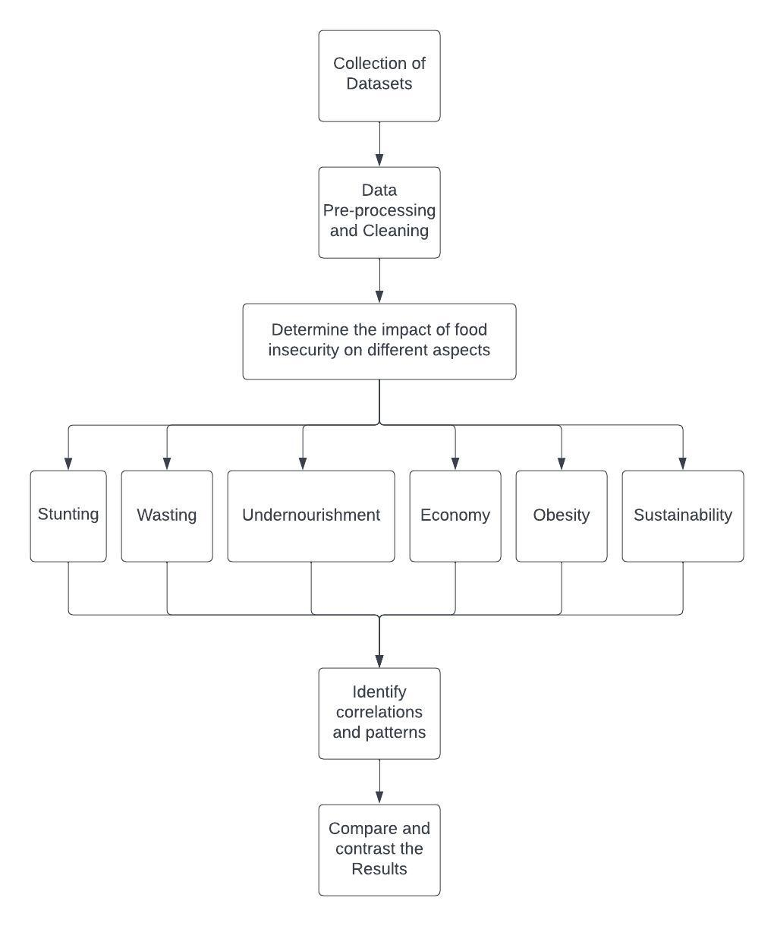  
*Fig 1. Flowchart of the workflow*

* 1. HOW THE PROPOSED MODEL DIFFERS FROM EXISTING MODELS

The proposed research differentiates itself from existing works by focusing on a comprehensive analysis of food insecurity across multiple aspects. While previous studies might have explored food insecurity in isolation or with limited scope, the model aims to provide a holistic understanding of the issue. By considering indicators such as stunting, wasting, obesity, undernourishment, economy, and sustainability, the aim is to uncover correlations and patterns that can reveal interconnected factors.

Furthermore, our project seeks to identify common patterns or trends across different countries, allowing for comparative analysis. This approach enables us to recognize underlying causes or shared impacts of food insecurity, which may inform policymaking and interventions on a broader scale. By addressing the broader context of food insecurity, the model offers a unique perspective and contributes to the existing body of knowledge on the subject.

1. RESULT

The analysis utilized public datasets from reputable sources like the Food and Agricultural Organization of the United Nations [6], the World Bank [8], and the World Resource Institute's Resource Watch [7]. An exploratory analysis using the Global Hunger Index was conducted to gain a global perspective. Ten countries from each continent, ranging from those with the worst to the best Global Hunger Index values were selected for the analysis.

The data has been gathered by collecting the values of the countries mentioned in Fig 3. It has been found that Africa has the highest Global hunger index rate as compared to other continents as per Fig 2. However, the hunger index has been gradually decreasing over the years and the situation has improved. Somalia in Africa, Haiti in North America, Venezuela in South America, Yemen in Asia, Papua New Guinea in Oceania, and Moldova in Europe have the highest hunger rates in the respective continents. Somalia still showcases the highest index value compared to other countries in the world making it the most food insecure.

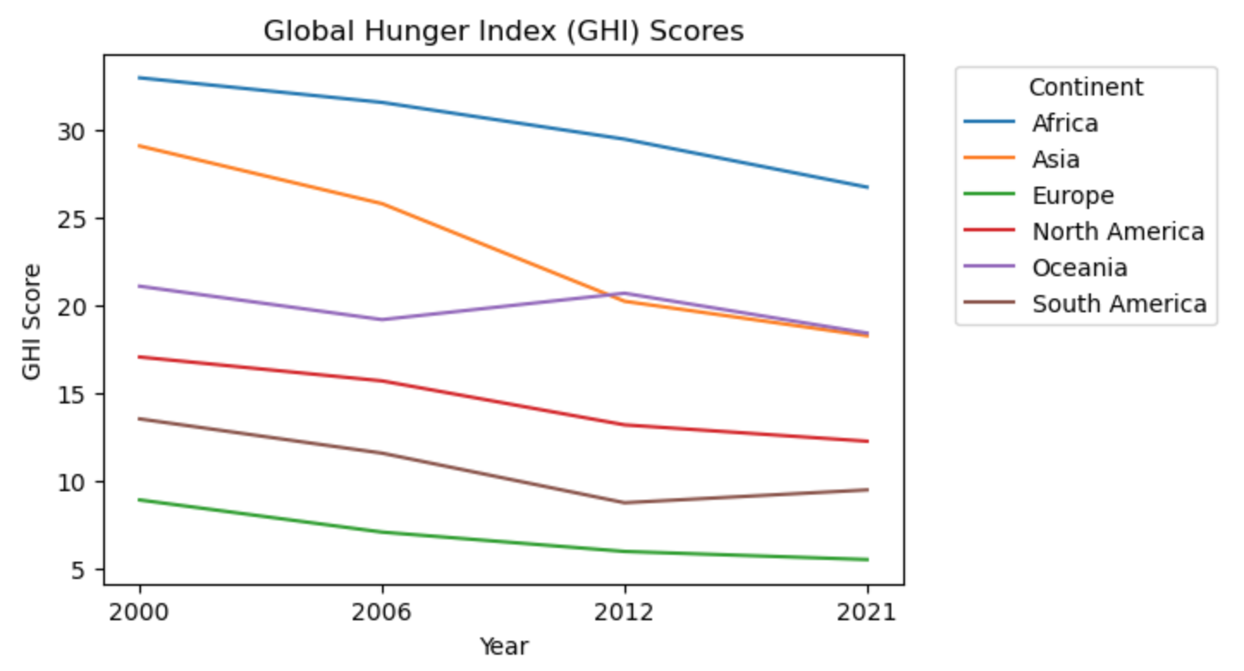  
*Fig 2. Global Hunger Index - Continent-Wise Analysis*

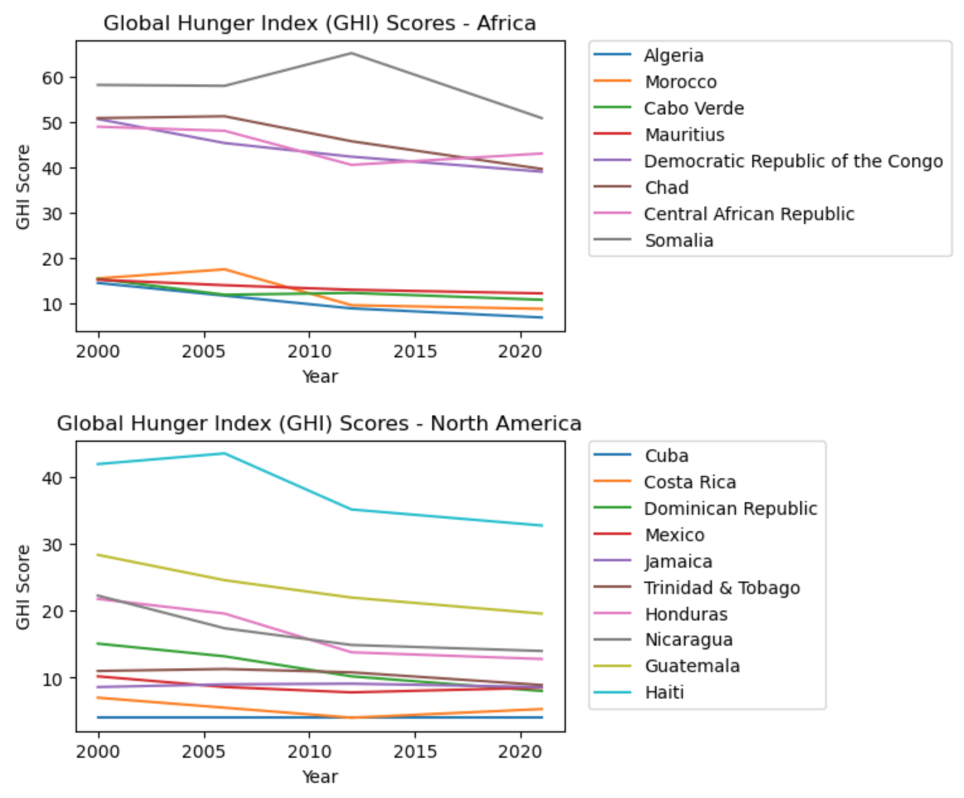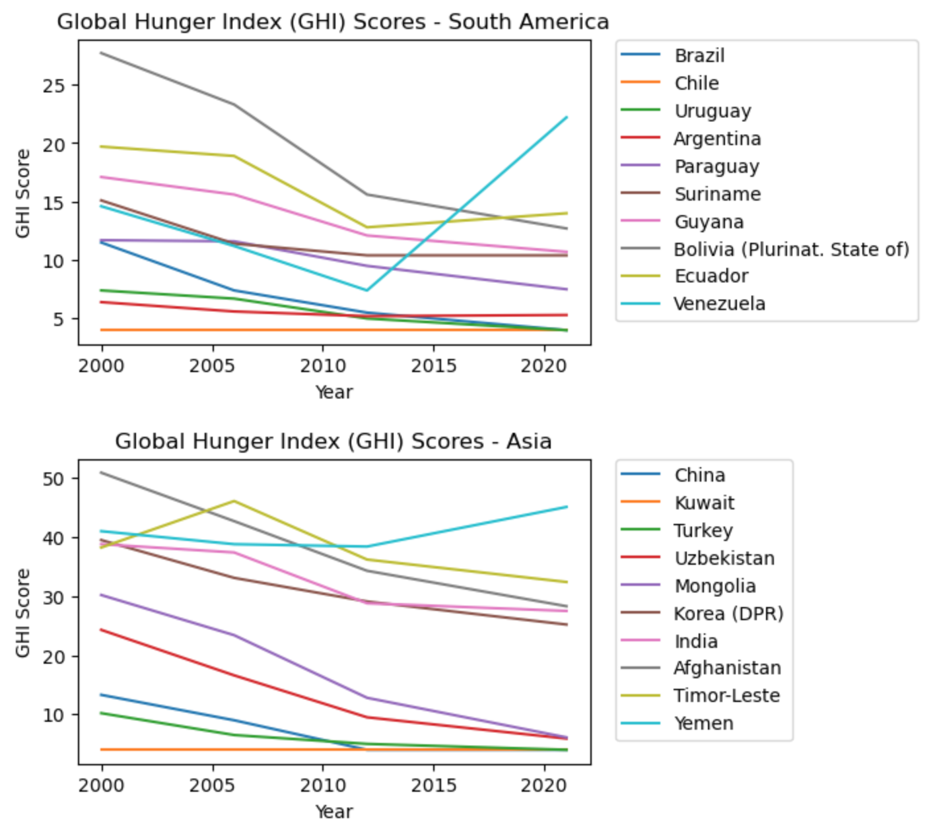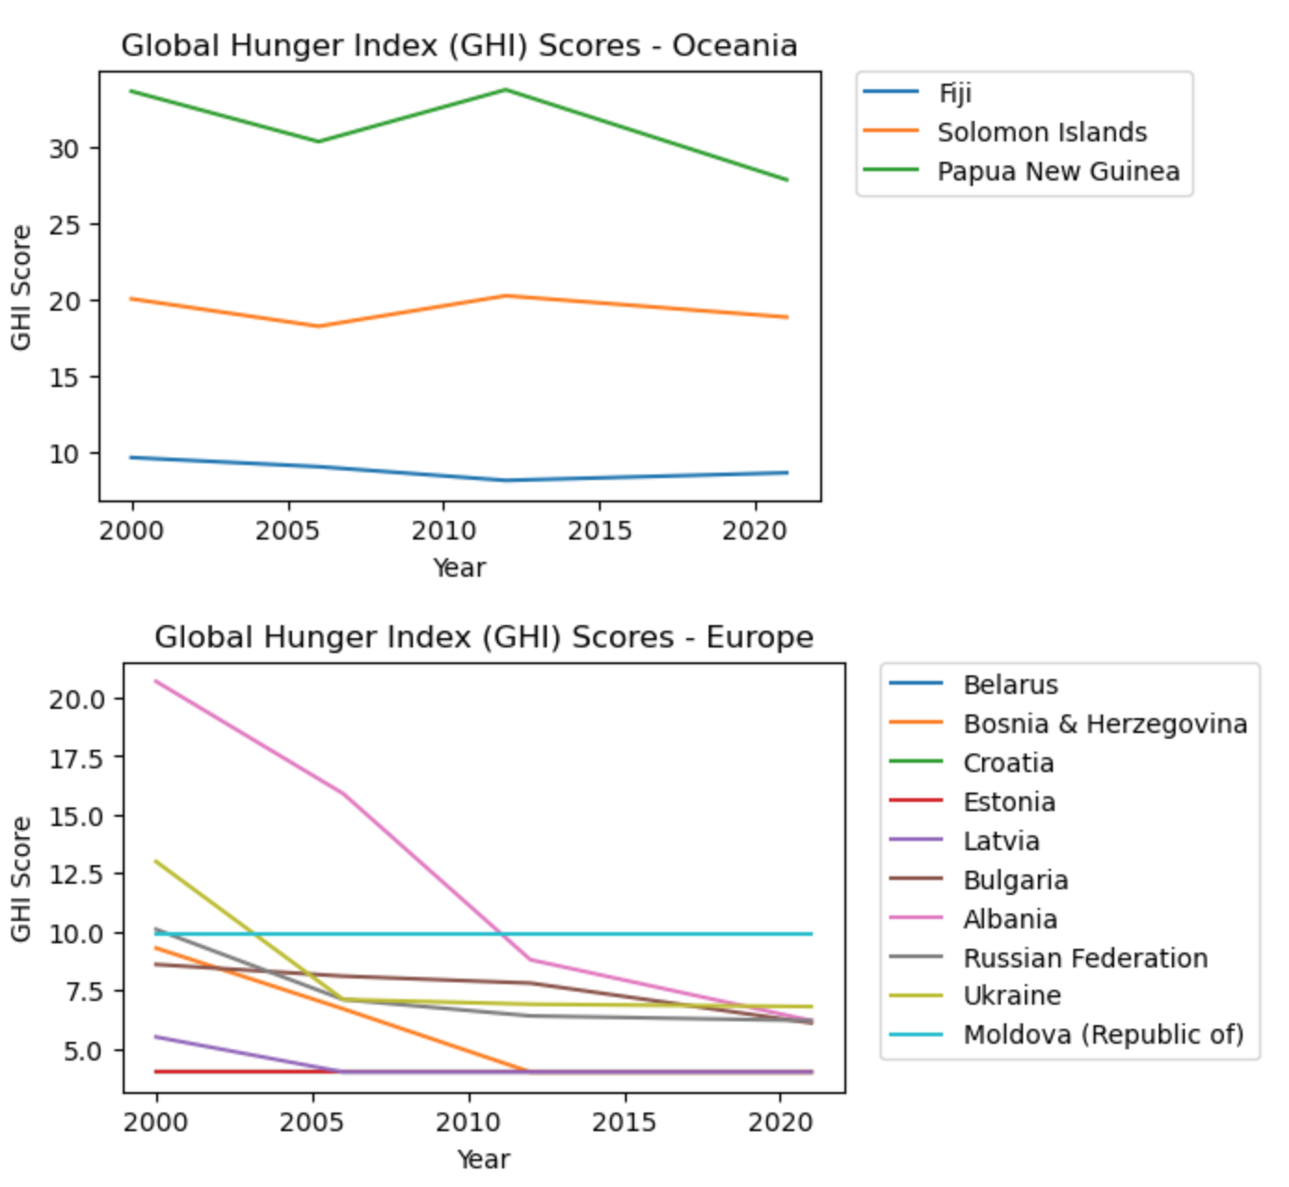

*Fig 3. Global Hunger Index - Country-Wise Analysis*

Analyzing the key indicators, following the results observed:

1. The level of malnutrition is the highest in Africa and the least in European countries. The graph was not steady over the years; peak graduations can be observed in Fig 4.

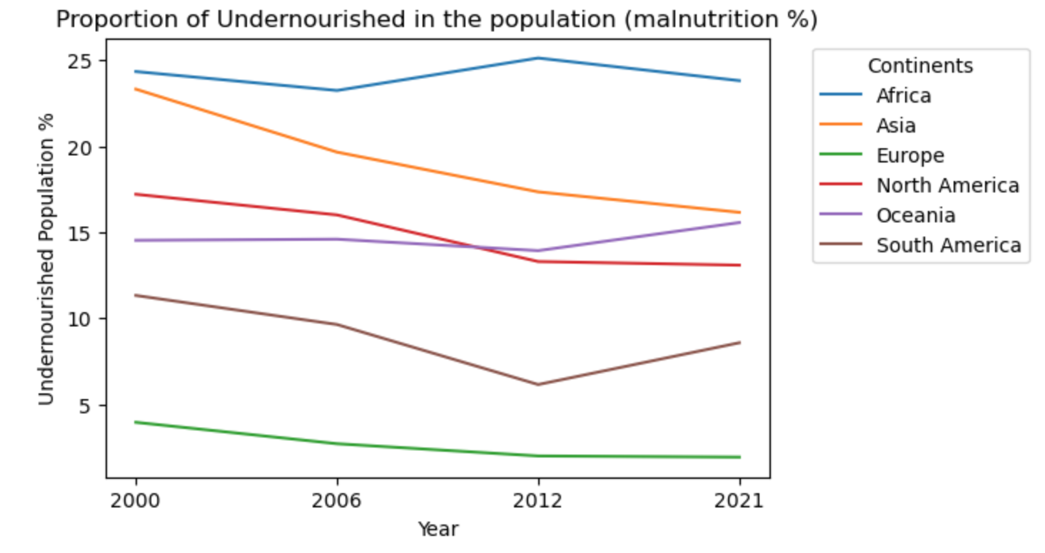

*Fig 4. Undernourishment Index - Continent-Wise Analysis*

2. Fig 5. shows that ‘wasting’ is also the highest in Africa but a gradual increase occurred in Oceania around 2012 and then it started to decrease. The weight proportion is seen as the most consistent in American continents.

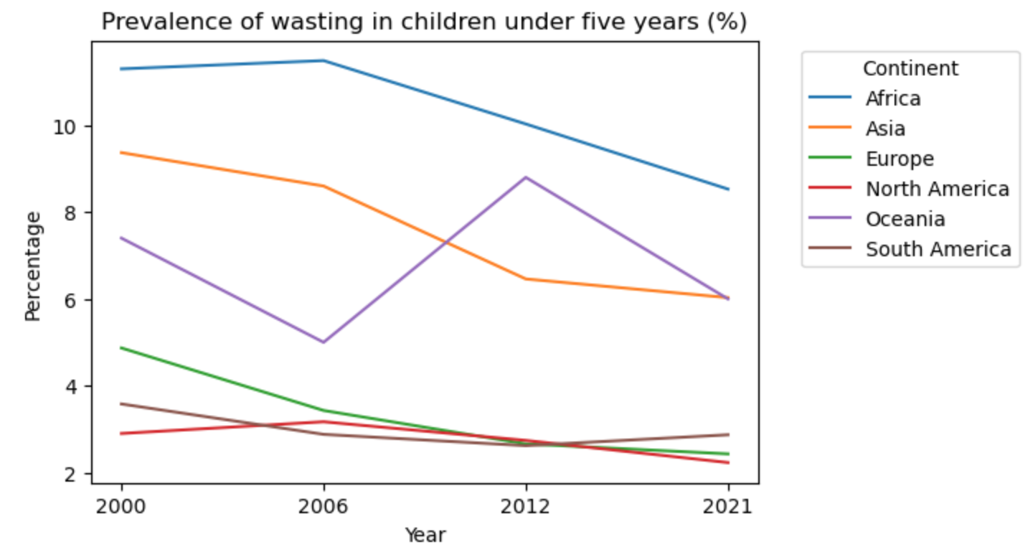*Fig 5. Wasting Index - Continent-Wise Analysis*

3. In Fig 6, the highest number of deaths occurred because of food insecurity is also in Africa. The continents have been evolving and the no. of death has started to decrease as a lot and people are becoming more health-conscious and aware.

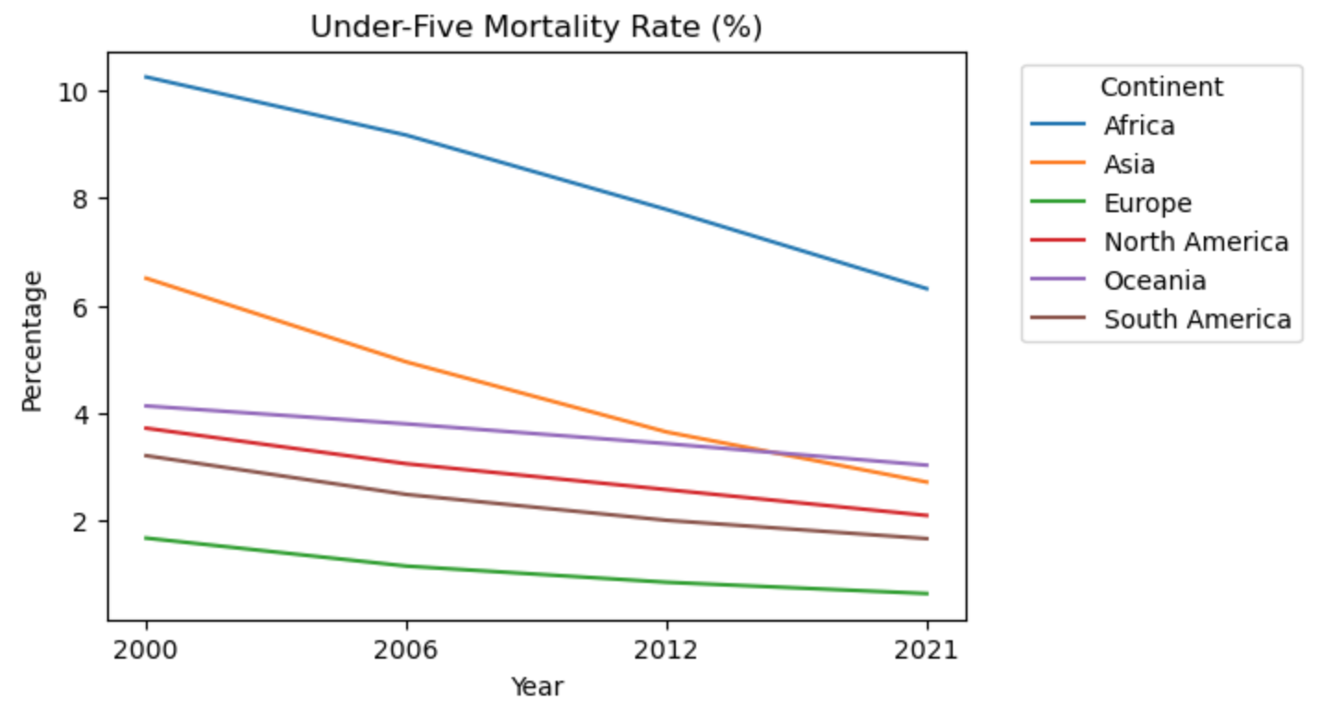

*Fig 6. Mortality Index - Continent-Wise Analysis*

4. Fig 7 and 8 show that the stunting rate is the maximum and the obesity level is the minimum in Africa. However, Oceania has the most obese people, around 25% and the level has been increasing ever since 2000.

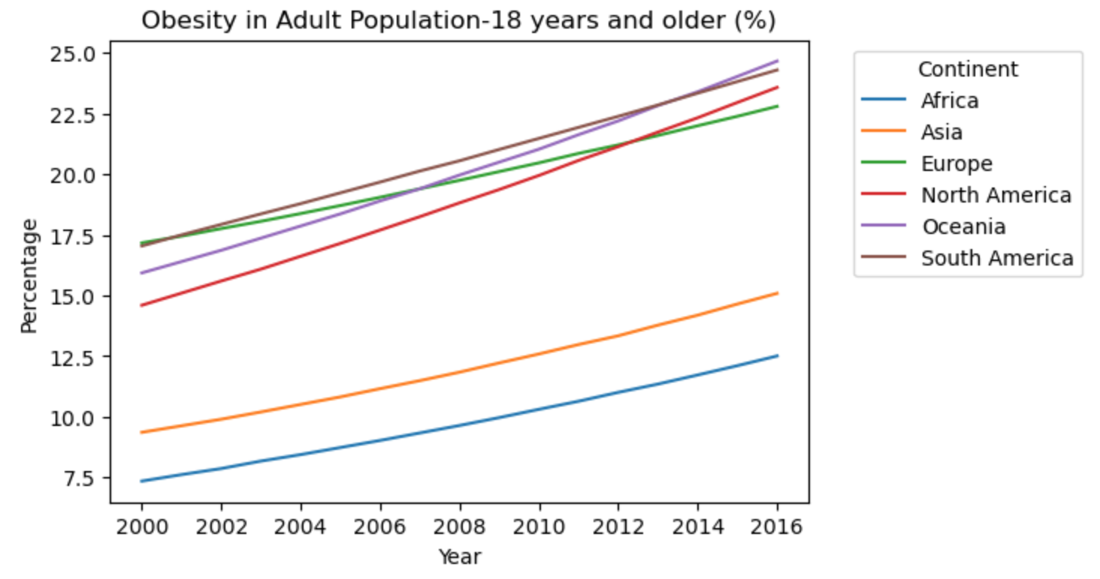

*Fig 7. Obesity Index - Continent-Wise Analysis*

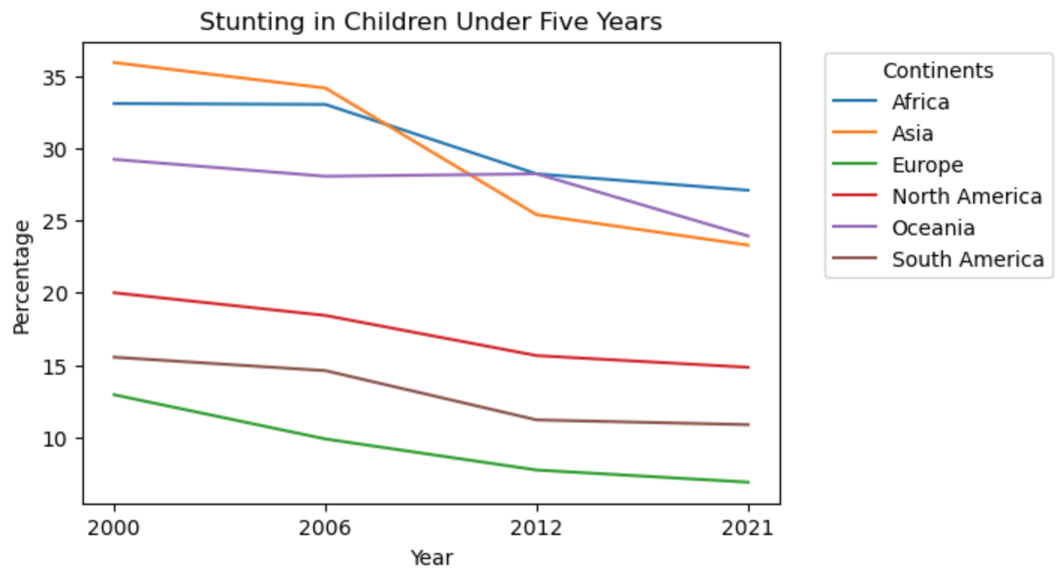*Fig 8. Stunting Index - Continent-Wise Analysis*

5. North America has the highest cost for a healthy diet, making it one of the most expensive regions to maintain a healthy balance of food but Africa, on the other hand, has the lowest cost for food. This is also one of the reasons for the high hunger rate in Africa. Poverty makes it even harder for people to access good food there as per Fig 9 and 10.

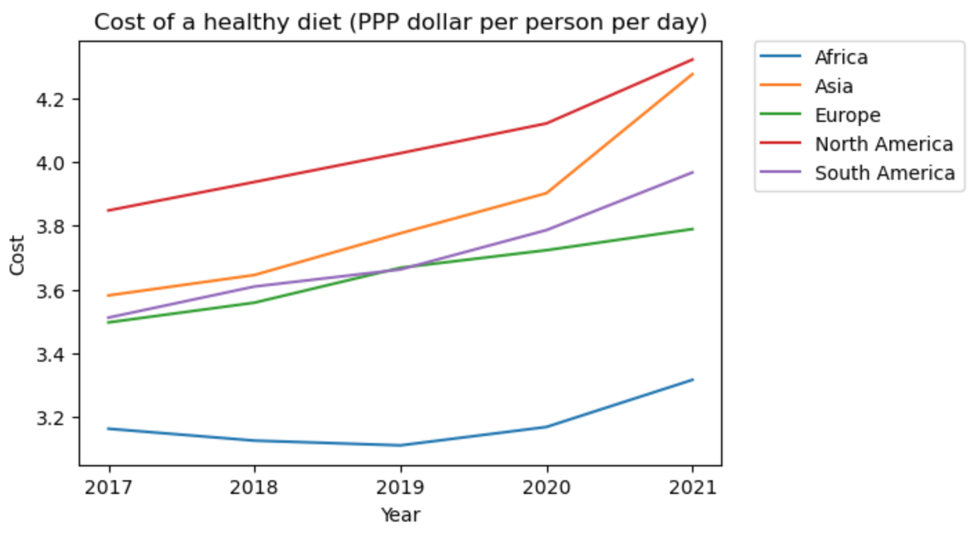*Fig 9. Cost of Diet Index - Continent-Wise Analysis*

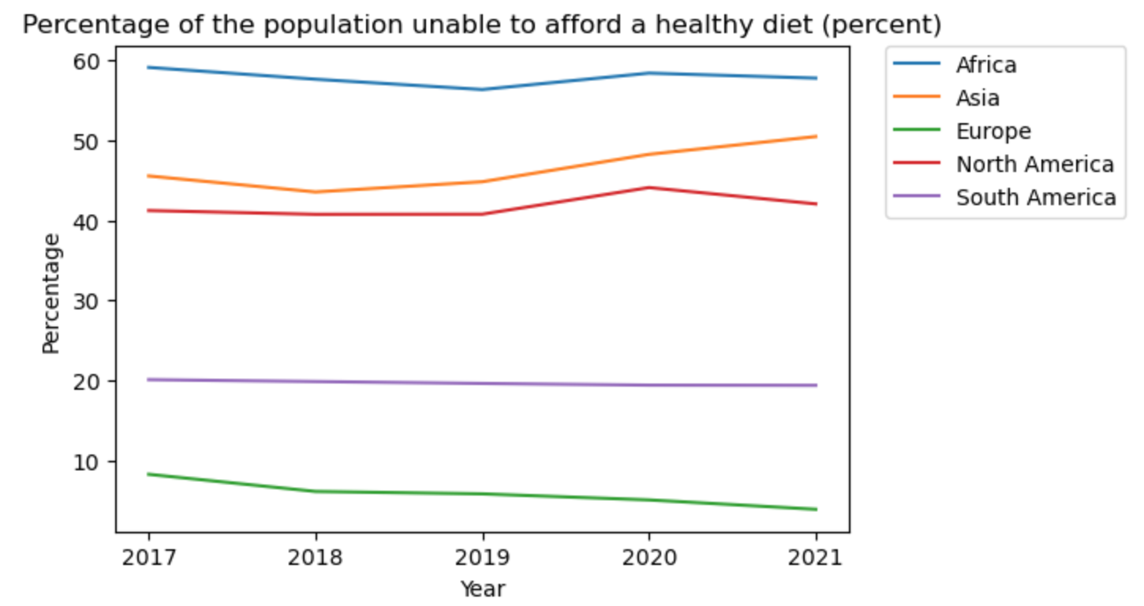*Fig 10. Unable to access healthy diet Index - Continent Wise Analysis*

6. It is also found that on the environmental level, the usage of pesticides and Insecticides helps to understand the degraded quality of agriculture fields, which in turn affects the food produced and in turn affects the food intake by a person according to Fig 11 and 12. The quality of food produced affects Asian and South American countries the most over the years which raises the question of environmental sustainability. On the other hand, Oceania and Africa use the products the least and rely on natural farming.

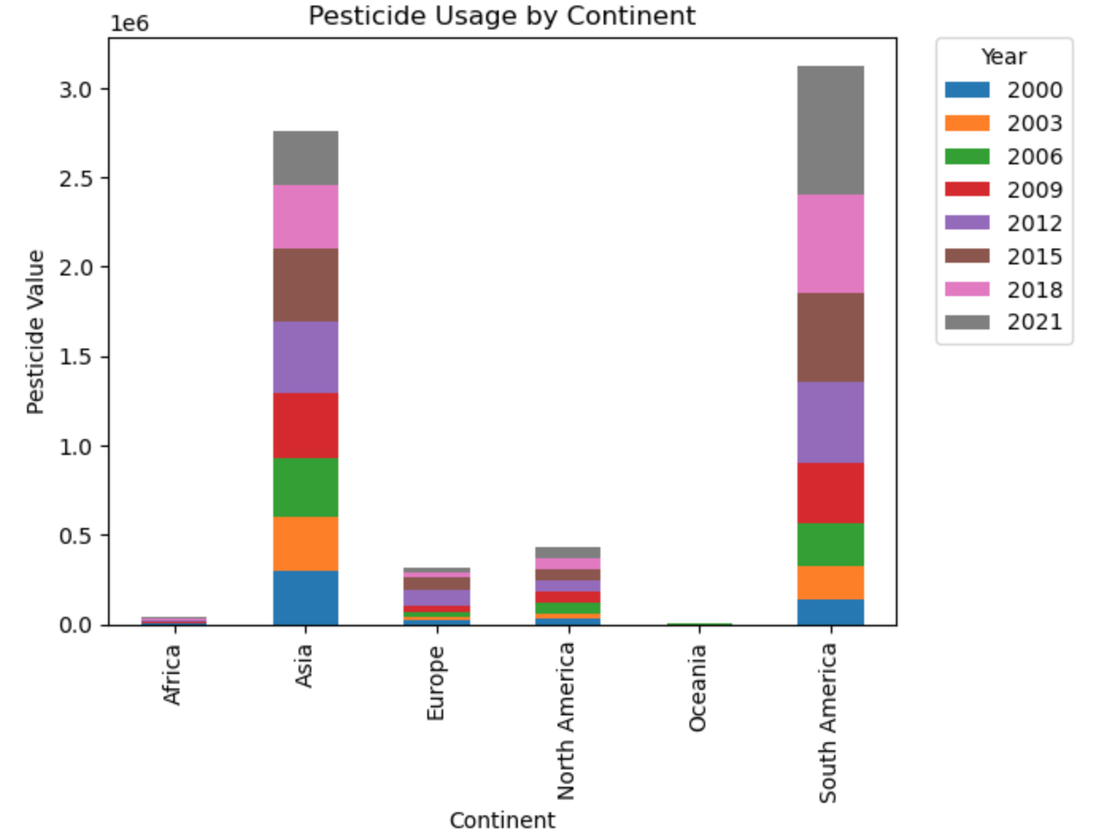

*Fig 11. Pesticide Usage - Continent-Wise Analysis*

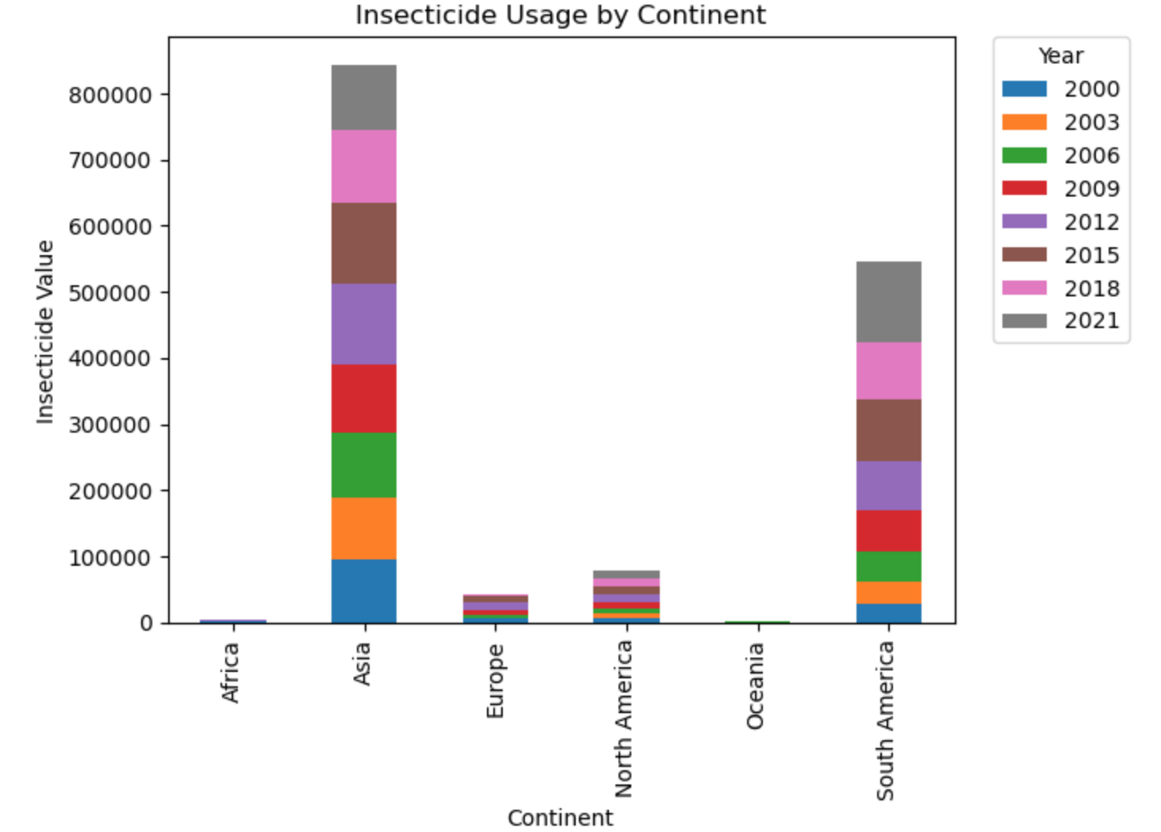

*Fig 12. Insecticide Usage - Continent-Wise Analysis*

Africa faces significant challenges related to malnutrition and food insecurity, while Oceania struggles with increasing obesity rates. The levels of food insecurity have been decreasing over the years for all the continents and it is evident through these graphs that much awareness and improvements are being made on the issue. European and American countries showcase the most consistent and stable index levels indicating a rich and healthy lifestyle.

5. LIMITATIONS AND CHALLENGES

Some of the challenges and limitations of our approach include:

1. *a. Data Availability and Quality:* One significant challenge was the availability and quality of data from public datasets. We wanted to conduct our analysis on datasets from reputable sources, because of which some regions or countries did have a lack of comprehensive consistent data. Incomplete or inconsistent data was the main limitation of our approach.
2. *b. Generalization to Global Context:* Our approach focused on a global perspective which might have prevented us from adequately capturing regional or local causes of food insecurity.

*c. Causality and Correlation:* Despite employing statistical techniques, establishing causality between food insecurity and certain factors is a challenge because correlations identified in the data analysis do not necessarily imply causation and other confounding variables may influence the relationships.

The proposed approach is designed for a global analysis, and its performance may not be optimal for small-scale or localized studies with specific target data requirements. Fine-grained analyses at the local level might require more targeted and context-specific methodologies. The approach also fails to specifically address the impacts of humanitarian crises or natural disasters on food insecurity. The COVID-19 epidemic, the war in Ukraine, and years of crop failures due to climate change have increased undernourishment in most of the world [11].

These limitations arise due to the complexity and multifaceted nature of the global food insecurity issue. Gathering comprehensive and unbiased data from diverse regions is a challenging task and the data itself may be subject to biases that may not fully reflect the rapidly changing nature of food insecurity. Despite these limitations, the proposed approach can provide valuable insights and serve as a foundation for addressing global food insecurity.

1. CONCLUSIONS AND FUTURE WORKS

The analysis of global food insecurity using exploratory data analysis yielded valuable insights into the complex nature of food insecurity worldwide. According to the key indicators of food insecurity, it is evident that African countries are the most affected by food insecurity followed by Asian countries and the European countries being the least affected. Moreover, by the start of 2021, it was observed that there is a gradual change or improvement in most of the key indicators of food insecurity including the steady decline of GHI score, the proportion of undernourished in the population, stunting, wasting and mortality rate in all the continents collectively. However, the trend tends to worsen and increase when it comes to the percentage of the population that are obese and the cost of a healthy diet over the years in all the continents. The usage of pesticides and insecticides is also on the rise, especially in Asian and South American countries. This analysis of trends over time allows for the monitoring of progress in combating food insecurity. Therefore, by identifying areas where improvements have been made and where challenges persist, stakeholders can evaluate the effectiveness of their efforts.

Future work of this approach can be to explore the effectiveness of different intervention strategies in combatting food insecurity and improving the well-being of affected populations. Leveraging emerging technologies like remote sensing and satellite imagery can offer new perspectives on monitoring agricultural productivity and predicting food insecurity patterns in vulnerable regions. Collaborating with experts from diverse fields, such as climate science, economics, and nutrition, can enrich the analysis and facilitate a more comprehensive understanding of food insecurity. By embarking on these future directions, researchers and policymakers can collectively work towards a world with reduced food insecurity, improved nutrition, and enhanced global well-being. The study's findings offer a strong impetus for continued efforts in addressing this critical global challenge and promoting sustainable, equitable, and resilient food systems.

REFERENCES

[1] S. Moradi *et al.*, “Food insecurity and adult weight abnormality risk: A systematic review and meta-analysis,” *European Journal of Nutrition*, vol. 58, no. 1, pp. 45–61, 2018. doi:10.1007/s00394-018-1819-6.

[2] J. Bhawra, S. I. Kirkpatrick, and D. Hammond, “Food insecurity among Canadian youth and Young Adults: Insights from the Canada Food Study,” *Canadian Journal of Public Health*, vol. 112, no. 4, pp. 663–675, 2021. doi:10.17269/s41997-020-00469-1.

[3] N. H. Broussard, “What explains gender differences in food insecurity?,” *Food Policy*, vol. 83, pp. 180–194, 2019. doi:10.1016/j.foodpol.2019.01.003.

[4] S. Moradi *et al.*, “Food insecurity and the risk of undernutrition complications among children and adolescents: A systematic review and meta-analysis,” *Nutrition*, vol. 62, pp. 52–60, 2019. doi:10.1016/j.nut.2018.11.029.

[5] C. Cafiero, S. Viviani, and M. Nord, “Food security measurement in a global context: The Food Insecurity Experience Scale,” *Measurement*, vol. 116, pp. 146–152, 2018. doi:10.1016/j.measurement.2017.10.065

[6] Faostat, https://www.fao.org/faostat/en/ (accessed June 25, 2023).

[7] Vizzuality, “Food,” *resourcewatch.org*. <https://resourcewatch.org/dashboards/food> (accessed June 25, 2023).

[8] “World Bank Open Data,” *World Bank Open Data*. https://data.worldbank.org/indicator/SH. STA.STN T.ME.ZS?view=chart (accessed Jul. 31, 2023).

‌[9] “Using Jupyter Notebook — Anaconda documentation,”*docs.anaconda.com*. https://docs. anaconda.com/ae-notebooks/user-guide/basic-tasks/apps/jupyter/index.html

‌[10] M. Mahadevan, “Step-by-Step Exploratory Data Analysis (EDA) using Python -,” *Analytics Vidhya*, Jul. 31, 2022. https://www.analyticsvidhya .com/blog/2022/07/step-by-step-exploratory-data-analysis-eda-using-python/

‌[11] “Food Security and Hunger,” *ONE Data & Analysis*. https://data.one.org/topics/food-security/ (accessed Jul. 25, 2023).

‌